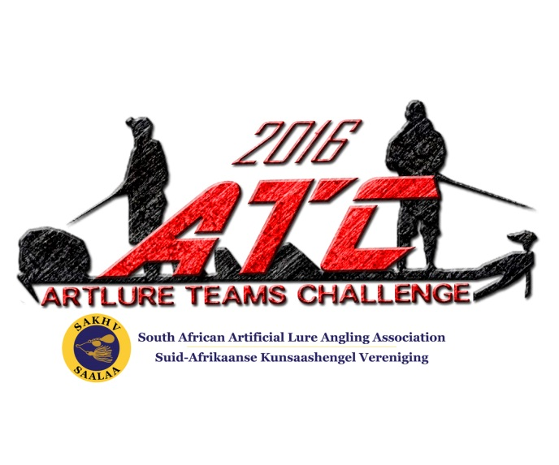

**TO:**

**ARTLURE TEAMS CHALLENGE: LOSKOP DAM 2016**

The second Artlure Teams Challenge (ATC) will be presented by the South African Artificial Lure Association at Loskop Dam on 22 October 2016. We hereby approach you for a possible sponsor for the (biggest BASS) caught during the event.

The ATC is a boat fishing tournament where only the bigger fish species are targeted. This is a significant movement away from the traditional artlure tournaments where the focus is on species diversity, and not necessary on big fish.

The ATC is a live weigh-in tournament and with teams weighing a bag of maximum six of any of the target fish species. The target fish species are: bass, catfish, carp, blue kurper, redbreast kurper and makriel.

The top three Teams will receive Team Prizes and the individual anglers who caught the biggest of each of the target species will receive species prizes consisting of top quality fishing tackle.

We believe this is a great opportunity to invest in the growing sport of Artlure angling and therefore ask if your company are willing to sponsor (2x spinning rods and 2x spinning reels) which will be given to one of the teams that finish in the top 3 position. Otherwize, you can consider giving a (spinning rod and reel for the biggest makriel) prize.

Depending on your sponsorship you may expect the following:

• Abundant exposure on the AFSA Facebook group and the event page through welcoming poster, mentioning’s etc.

• Use of your logo on the banner that we will be printing for this event

• Exposure via a report-back article to be published in Stywe Lyne Tight Lines magazine (mentionings, logos and photos)

• Share photos with branding and prizes on AFSA and SAALAA Facebook groups, Stywe Lyne Tight Lines Facebook page and group (11 000+ likes).

All the income made with this event will be used to finance SAALAA and will help the Executive to grow and maintain competitive Artlure angling in South Africa.

The event will be attended by some of the best artlure anglers from all provinces in South Africa and is also open for social artlure anglers.

We believe that the anglers participating in the ATC are definitely within your own marketing segments and an excellent opportunity to expand your market in this area. We also believe that this will be an excellent branding opportunity to show your support to the anglers, who are at the end of the day your customers.

We are looking forward to hear from you soon.

Yours sincerely

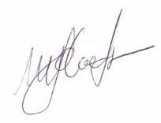

Magriet Coetzee

South African Artificial Lure Angling Association

Chairperson